Chapter 5 Exercises
- Write a SELECT statement that returns one row for each vendor that contains these columns from the Invoices table:
The vendor_id column
The sum of the invoice_total column
The result set should be sorted by vendor_id.
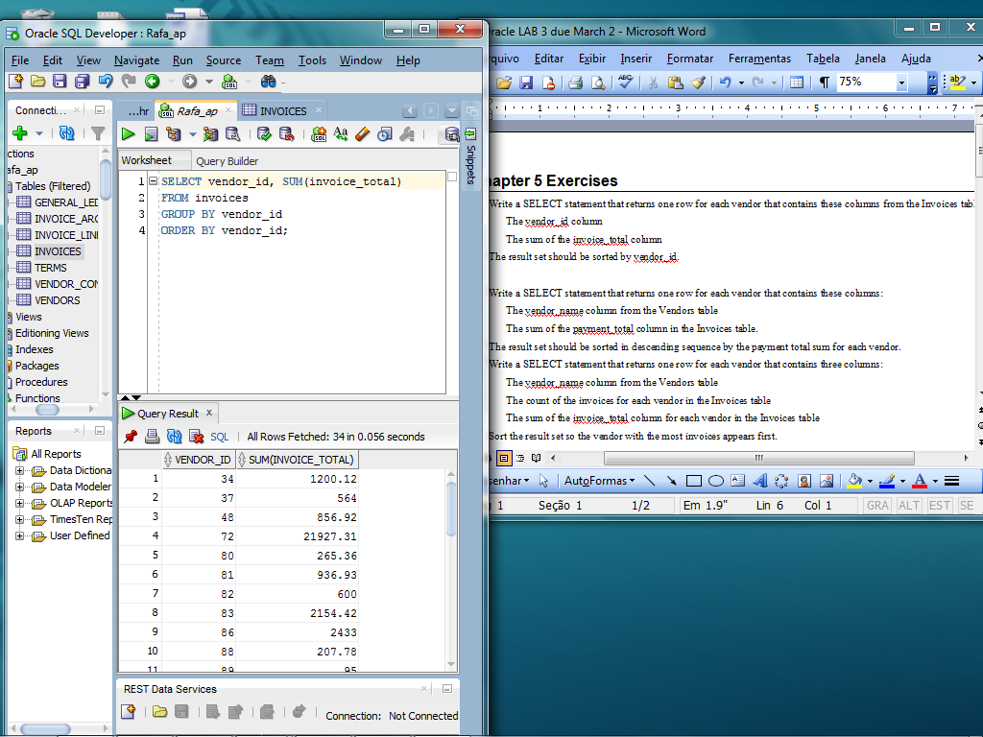
- Write a SELECT statement that returns one row for each vendor that contains these columns:
The vendor_name column from the Vendors table
The sum of the payment_total column in the Invoices table.
The result set should be sorted in descending sequence by the payment total sum for each vendor.
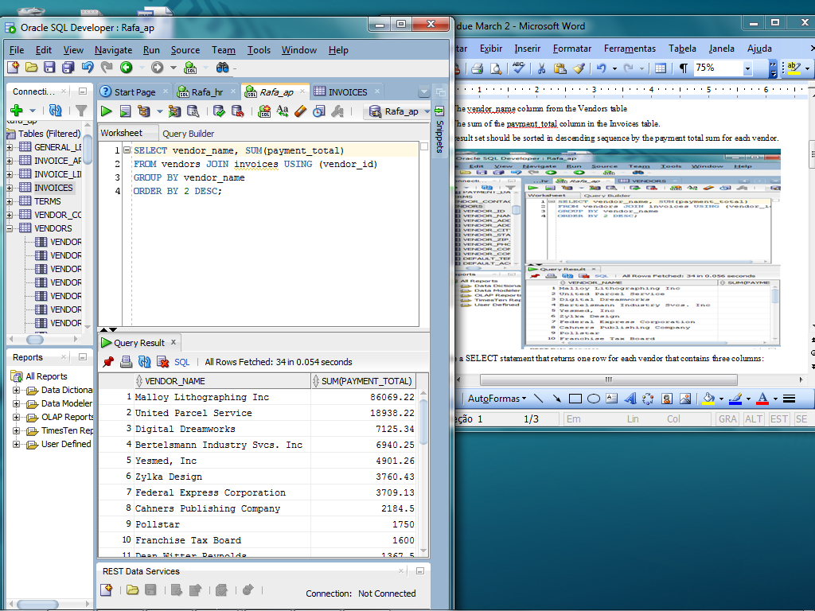

- Write a SELECT statement that returns one row for each vendor that contains three columns:
The vendor_name column from the Vendors table
The count of the invoices for each vendor in the Invoices table
The sum of the invoice_total column for each vendor in the Invoices table
Sort the result set so the vendor with the most invoices appears first.
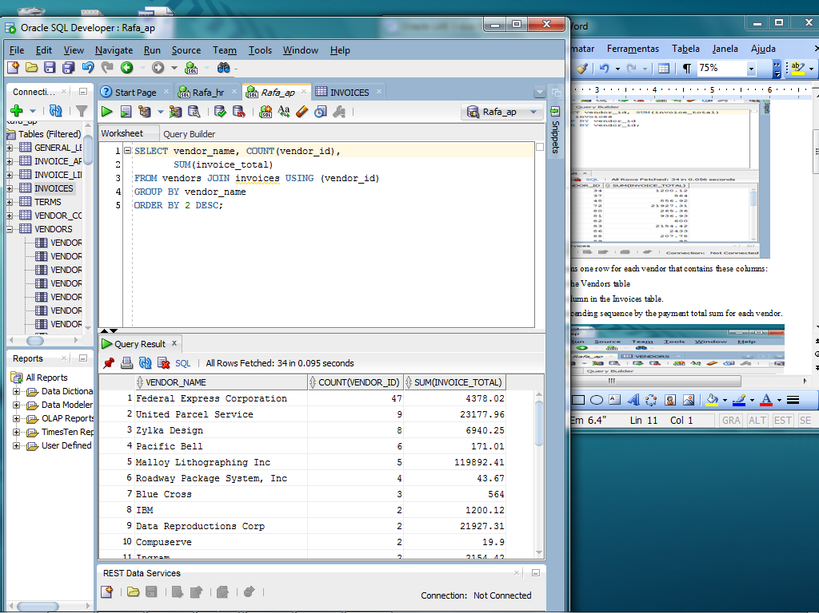
- Write a SELECT statement that returns one row for each general ledger acQcount number that contains three columns:
The account_description column from the General_Ledger_Accounts table
The count of the entries in the Invoice_Line_Items table that have the same account_number
The sum of the line item amounts in the Invoice_Line_Items table that have the same account-number
Filter the result set to include only those rows with a count greater than 1; group the result set by account description; and sort the result set in descending sequence by the sum of the line item amounts.
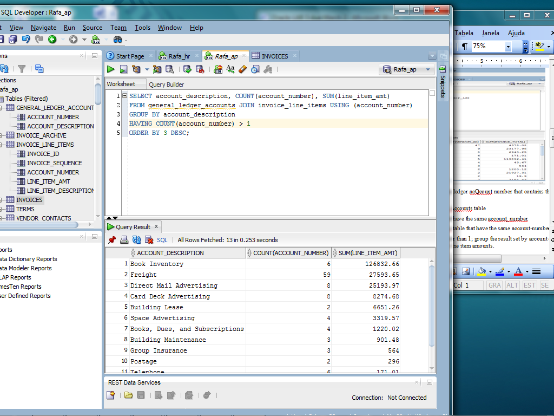
- Modify the solution to exercise 4 to filter for invoices dated in the second quarter of 2008 (April 1, 2008 to June 30, 2008). Hint: Join to the Invoices table to code a search condition based on invoice_date.
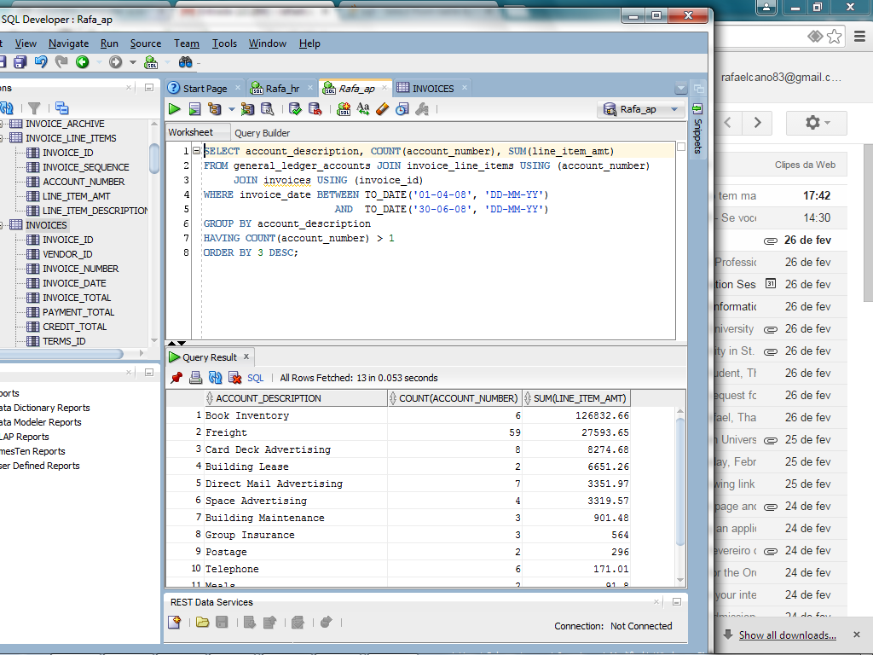
- Write a SELECT statement that answers this question: What is the total amount invoiced for each general ledger account number? Use the ROLLUP operator to include a row that gives the grand total. Hint: Use the line_item_amt column of the Invoice_Line_Items table.
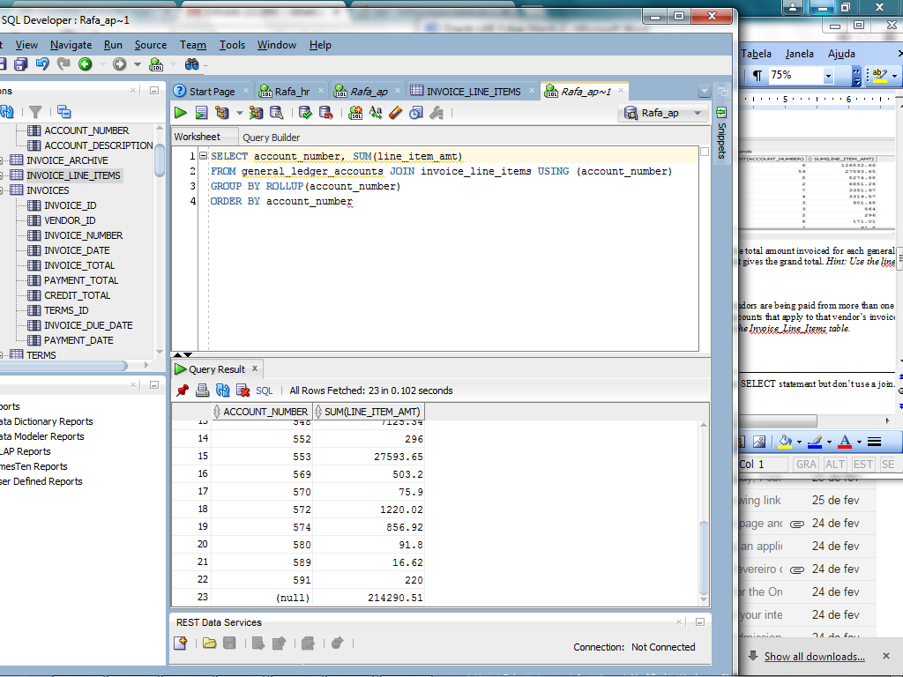

- Write a SELECT statement that answers this question: Which vendors are being paid from more than one account? Return two columns: the vendor name and the total number of accounts that apply to that vendor’s invoices. Hint: Use the DISTINCT keyword to count the account_number column in the Invoice_Line_Items table.
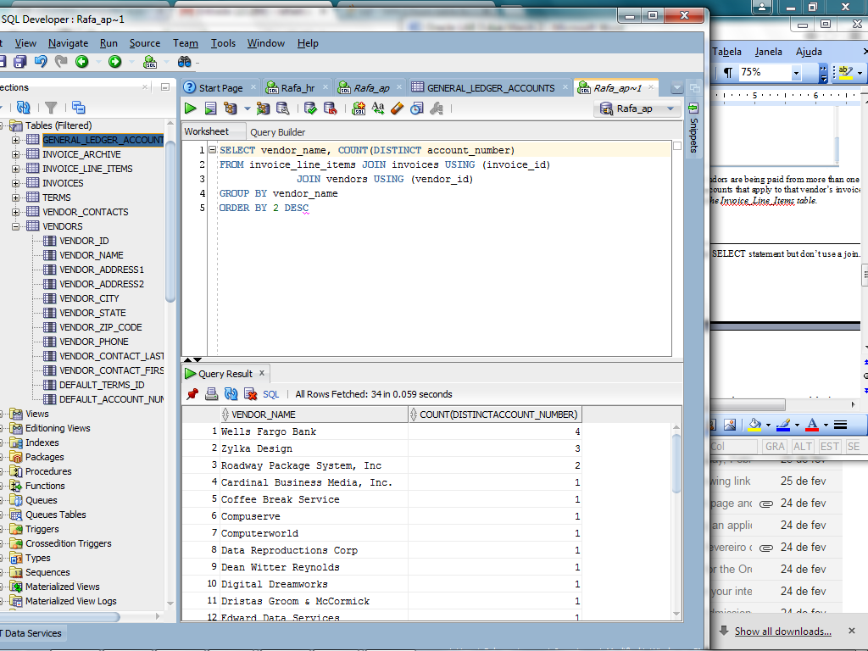

Chapter 6 Exercises
- Write a SELECT statement that returns the same result set as this SELECT statement but don’t use a join. Instead, use a subquery in a WHERE clause that uses the IN keyword.
SELECT DISTINCT vendor_name
FROM vendors JOIN invoices
ON vendors.vendor_id = invoices.vendor_id
ORDER BY vendor_name
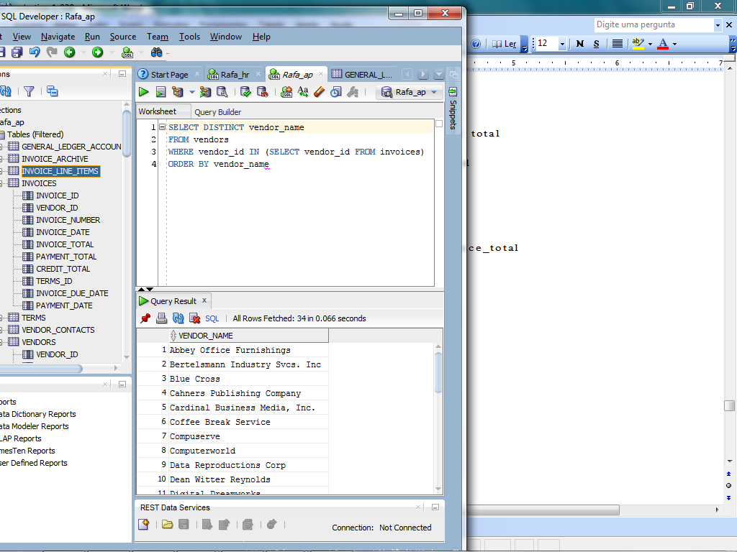

- Write a SELECT statement that answers this question: Which invoices have a payment_total that’s greater than the average payment_total for all paid invoices? Return the invoice_number and invoice_total for each invoice.
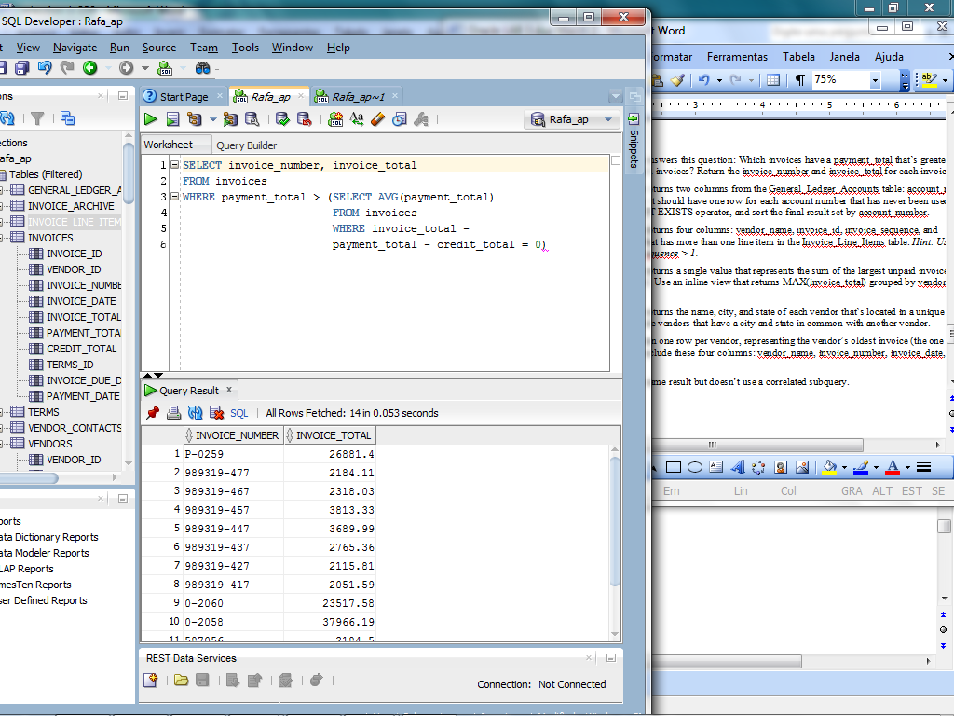
- Write a SELECT statement that returns two columns from the General_Ledger_Accounts table: account_number and account_description. The result set should have one row for each account number that has never been used. Use a subquery introduced with the NOT EXISTS operator, and sort the final result set by account_number.
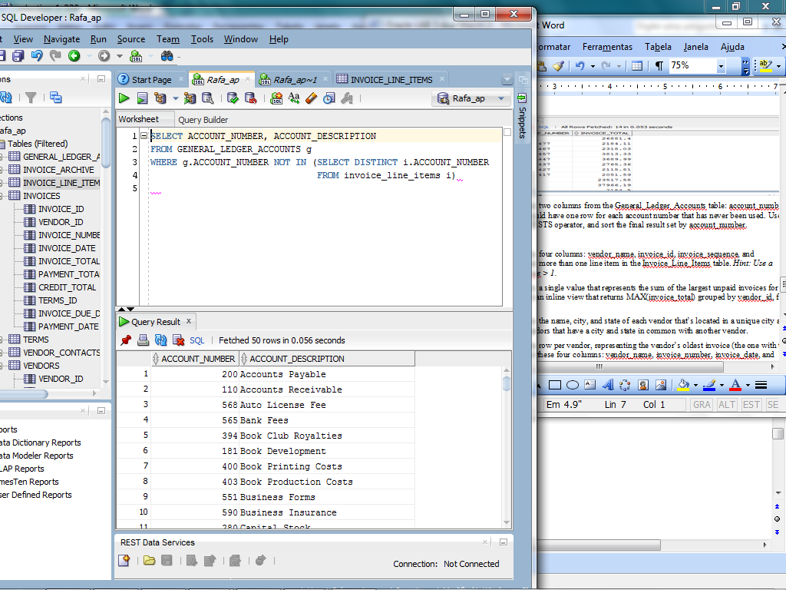

- Write a SELECT statement that returns four columns: vendor_name, invoice_id, invoice_sequence, and line_item_amt for each invoice that has more than one line item in the Invoice_Line_Items table. Hint: Use a subquery that tests for invoice_sequence > 1.
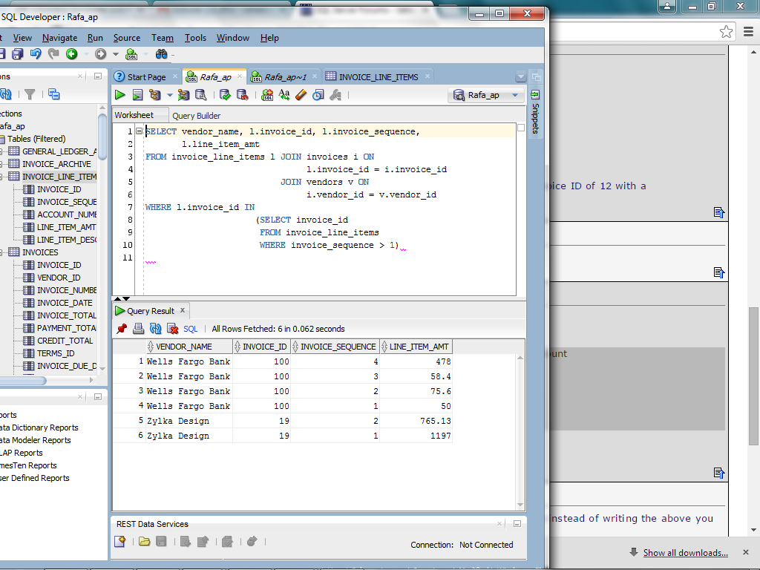
- Write a SELECT statement that returns a single value that represents the sum of the largest unpaid invoices for each vendor (just one for each vendor). Use an inline view that returns MAX(invoice_total) grouped by vendor_id, filtering for invoices with a balance due.
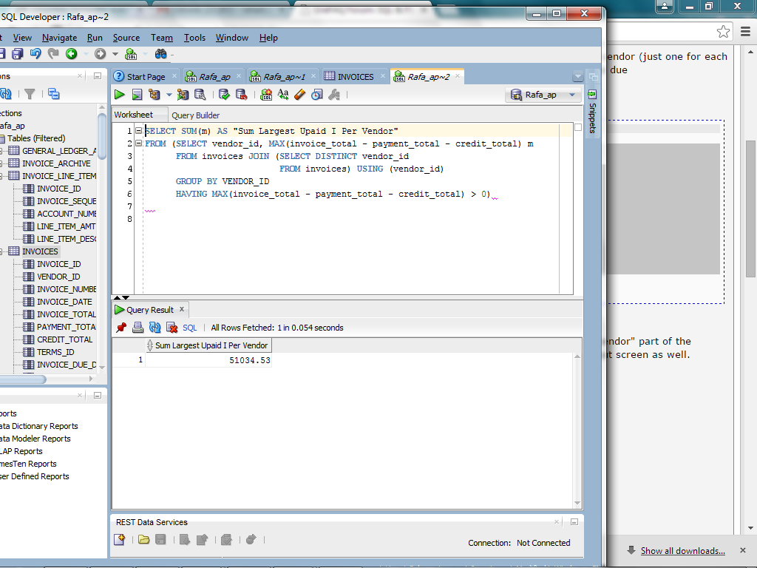

- Write a SELECT statement that returns the name, city, and state of each vendor that’s located in a unique city and state. In other words, don’t include vendors that have a city and state in common with another vendor.
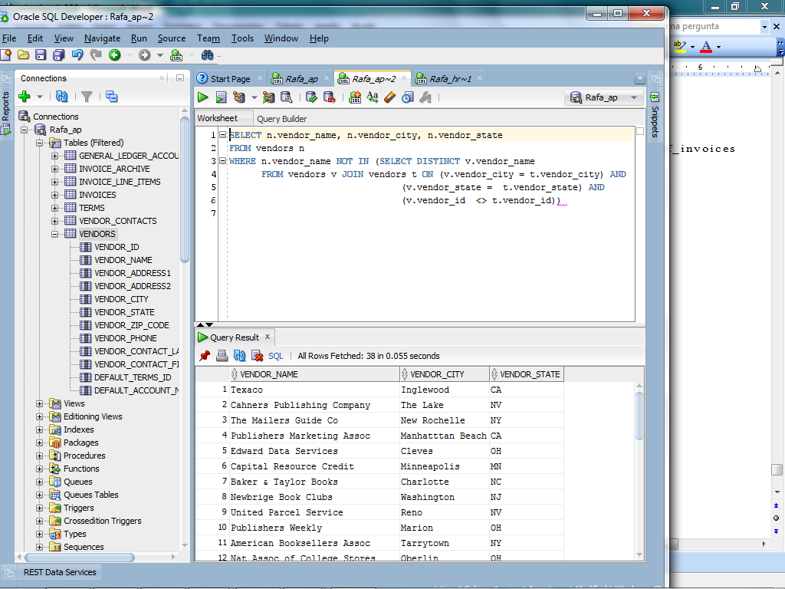
- Use a correlated subquery to return one row per vendor, representing the vendor’s oldest invoice (the one with the earliest date). Each row should include these four columns: vendor_name, invoice_number, invoice_date, and invoice_total.
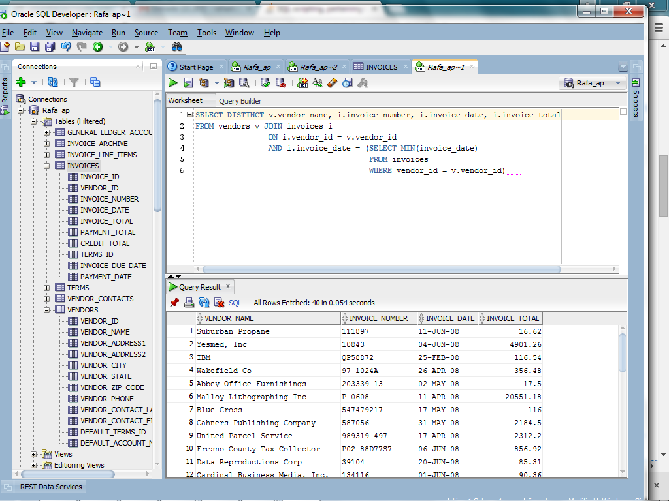

- Rewrite exercise 8 so it gets the same result but doesn’t use a correlated subquery.
